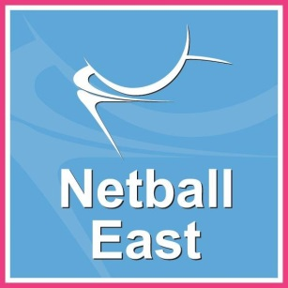

**Assistant Coach for the Regional Performance and   
Regional Academies**

**Job Description**

**Performance Management**

**Essentials**

* Communicating instructions and commands using clear, simple language.*
* Demonstrating an activity by breaking the task down into a sequence.*
* Encouraging athletes to gain and develop skills, knowledge and techniques required foe netball.*
* Ensuring that participants train and perform to a high standard of health and safety at all times.*
* Inspiring confidence and self-belief.*
* Adapting to the needs and interests of group or individual athletes.*
* Acting as a role model, gaining the respect and trust of the athletes, coaches’ parents and support staff that you work with.*
* Evaluating performance of the athletes and providing suitable feedback, balancing criticism with positive and motivating comments.*
* Assessing strengths and weaknesses in an athlete’s performance and identifying areas for further development.*
* Working to a high legal and ethical standard at all times, particularly in relation to issues such as child safeguarding and health and safety requirements.*

**Desirables**

* Developing knowledge and understanding of fitness, injury, sports psychology, nutrition and sports science (desirable)*

*\*In conjunction with the Performance Pathway Coach and other Assistant Coaches*

**Planning and Administration**

* Occasionally, coordinating participants' attendance at meetings and other sports events.
* Planning and delivering of sessions for groups and/or individuals.
* Occasionally, plan and lead sessions in the absence of the Performance Pathway Coach (PPC)
* Complete and forward expense claims forms to the relevant personnel.