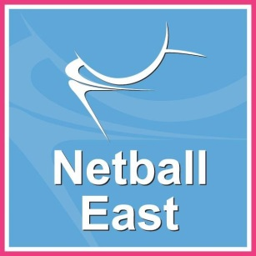
PEFORMANCE COACHING:
EXPRESSION OF INTEREST

If you are interested in Performance Coaching in the East Region, please complete this and return it to east@englandnetball.co.uk Must be returned by Friday 10th June 2016
Our regional performance lead will be in contact to discuss with you this opportunity further.
Contact Details
Name
Surname
Address

Home Tel No.
Mobile Tel No.
Email Address

Would you like to be added to our distribution lists for more information about netball news and events in the East? (including Netball East Digi News) Y / N (please delete as appropriate)
Please select the most suitable statement below:
€ I would like to be considered assistant coach for Regional Academy at Braintree
€ I would like to be considered assistant coach for Regional Academy at Oaklands
€ I would like to be considered assistant for Regional Performance Academy
€ I am interested in coaching with my County Academy.
Please list below any coaching qualification and training courses relevant to this role:
Qualifications | Date qualified
A Bit About You…

In the box below, please detail why you would like to apply for this post?
What would you consider to be your strengths and how can you help to enhance
and support the performance pathway in the East Region?

